Lab 2: GO CONCURRENCY
Net-Centric Programming
Lecturer: Le Thanh Son
Student Name: Chau Thanh Phat
Student ID: ITITIU21135

Part 1: Your First Goroutine
  - Three Counter
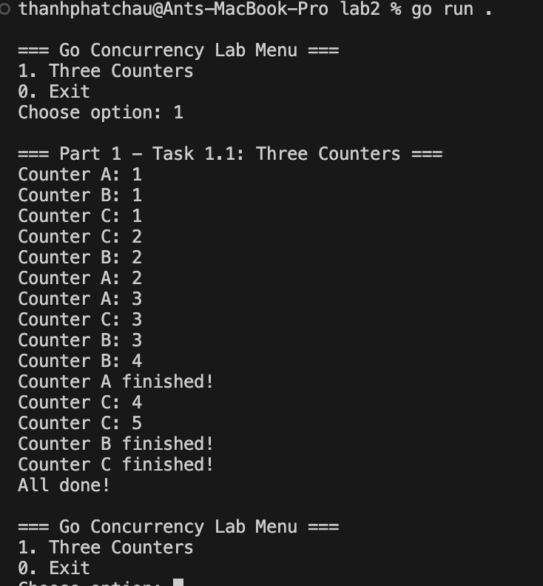
  - Website fetcher
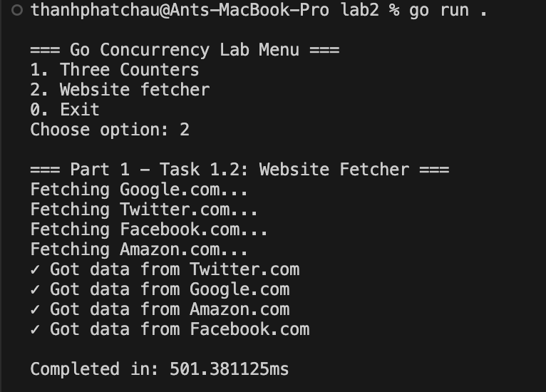

Part 2: Channels
2.1 Calculator with channels
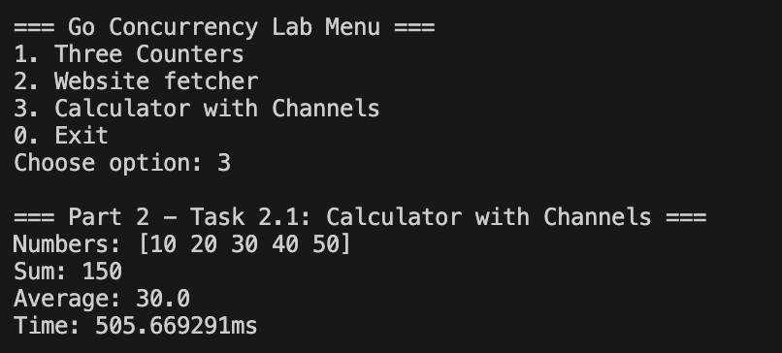
2.2 Message Queue
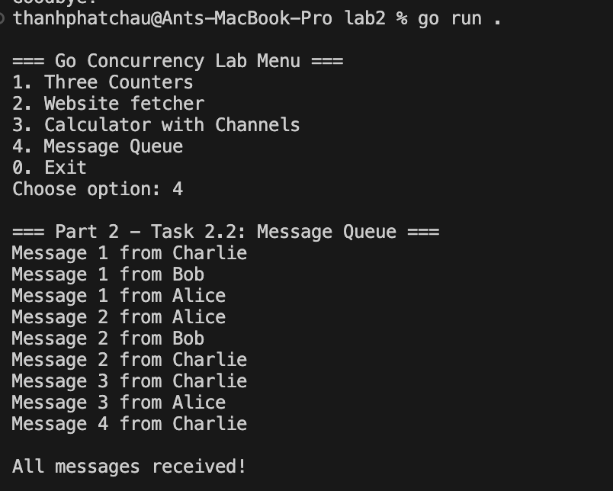

Part 3: WaitGroup
3.1 File downloader
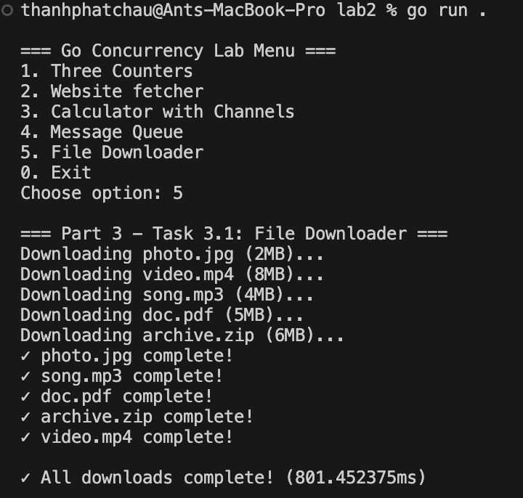

3.2 Number processor
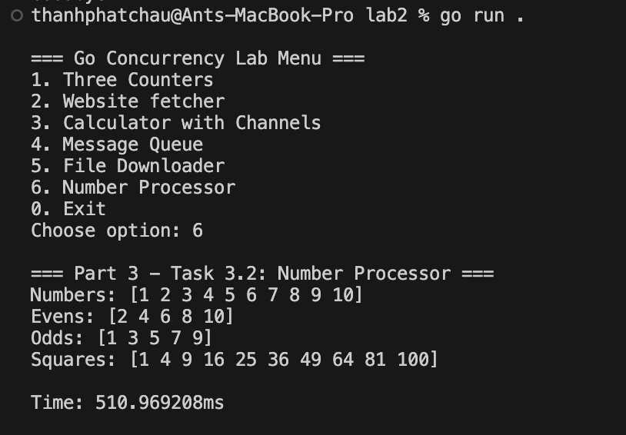

Part 4: Select
4.1 Search Rate
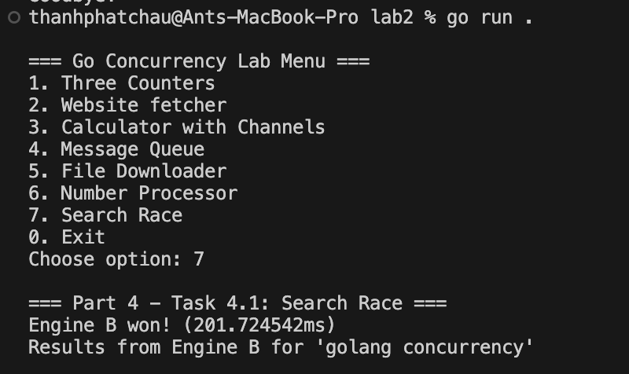

Part 5: Real – World Application
5.1 Library simulation
